About us
Welcome to TREESHA EDUCATIONAL SERVICES, also known as TES Kolkata. As the premier study abroad consultancy in Kolkata, we assist students in securing admissions to top universities worldwide. Our services consider academic achievements, financial situations, and other relevant factors to ensure the best fit for each student. We take pride in being a trusted partner for Indian students in their educational journeys abroad.

DIRECTOR VOICE
Thank you for your interest in TREESHA EDUCATIONAL SERVICES. I welcome you to become a part of our TES team. We believe that all your queries regarding overseas education will be solved here. I promise to suggest you the right course & country which will help you to fulfil your dream of studying abroad.
Regarding Expenses: You can get education loan from almost all the National Banks. In addition students are allowed to work 20 hrs. /week & fulltime during the vacation to supplement their expenses during the study period. However you should think that your main purpose is to study not to earn money.
Each year we receive hundreds of queries from the students. But mostly students contact us after personal recommendation from friends & relatives. We really thank those people who recommended us for the last few years & we believe they are the part of our extended TES family.
I think following are the key points you should consider while you are applying to study overseas. Personal safety\ Low cost of living\ Low tuition fees\ High quality academic programs\ Internationally reputed Institution\ English language assistance\ Friendly and helpful people\ Opportunity to work whilst studying\ Positive graduate outcome\ Qualified teaching staff.
Some institutions provide free airport reception services. Students should inform (If you choose to make your own travel arrangement) us well in advance to avail this facilities. Also you should keep in mind that you are not traveling to overseas just as a visitor. So you should also learn and respect that country's culture & language. Once you apply through us you become the part of our TES family. If you hen do not hesitate to contact us. It will be pleasure for me to serve you at the earliest.
I look forward to welcoming you.
- Sanjib Maity

OUR TEAM only one image will be set and content
We, as an organization to help students get the universities of their choice, keeping in mind the overall academic, financial and other appropriate considerations, are proud to have been entrusted to the services of Indians students since 2014.
This agency of ours, having been fully equipped with manpower and the materials that are required for the efficient working of it, and also for having great competitiveness in this world market, we are more than confident that we can much extensively serve the people of India: the aspiring students, their parents and relatives, and those who have some influencing role in sending student abroad for higher education.
TREESHA EDUCATIONAL SERVICES. is pleased to have work relationship with lots of highly accredited institutions of higher education, mostly from the UK, CANADA, USA, AUSTRALIA, IRELAND, NEW ZEALAND and such others.
Our popularity and trustworthiness among the students within the country and our credibility with the colleges and universities abroad, have both contributed in the success in our efforts.
TES Kolkata has one branches networking throughout the country, located at Delhi NCR. We still are in the process of extending branches as needed. TES, is pleased to have work relationship with lots of highly accredited institutions of higher education, mostly from the United Kingdom, Australia, Canada, Germany, Ireland, New Zealand and such others.
Our popularity and trustworthiness among the students within the country and our credibility with the colleges and universities abroad, have both contributed in the success in our efforts. Here are other institutions that are coming forward to joining hands with us to collaborate in the fields of recruitment of Indians students at their institutions.
Activities we, at Treesha Educational Services have been successfully conducting the following activities in our premises, besides our main job of counselling students to study abroad. The major activities being conducted with great client satisfaction are Student Counselling Preparation of documents for Admission and the visa Preparation of total and financial documents.

Our Mission
Empowering youth by guiding them to pursue education at top institutions, paving the way for prestigious roles in society through enhanced career opportunities. We are dedicated to supporting students in achieving their life goals and unlocking their full potential.
Our Vision
Treesha Educational Services envisions a world where quality education is accessible to all. We strive to empower students through expert guidance, innovative learning, and global opportunities. By integrating technology, personalized mentorship, and ethical practices, we aim to transform education into a pathway for lifelong success and excellence.
Our Values
At Treesha Educational Services, we uphold integrity, excellence, innovation, inclusivity, and commitment to student success. We prioritize ethical guidance, quality education, and lifelong learning. Our values drive us to empower students, foster global opportunities, and create a transformative educational experience that shapes future leaders and professionals.

Services
HIGH QUALITY ACADEMIC PROGRAMS
Parents and students receive clear, precise guidance on the necessary documentation for student visas, along with support in visa application submission and coordination throughout the process. Our expert assistance ensures a smooth and hassle-free experience, helping students fulfill all requirements efficiently and confidently.

EXPERT COUNSELORS WITH KNOWLEDGE OF MULTIPLE COUNTRIES
Booking flight tickets in advance and staying updated on available discounts help students travel to their destinations more affordably and conveniently. Proper planning ensures a smooth journey while minimizing travel costs.
ENGLISH TEST GUIDANCE
(IELTS, TOEFL)
At Treesha Educational Services, we offer expert guidance to students and parents in selecting the right courses that align with individual career goals. We provide comprehensive information on available programs and universities, ensuring informed decisions for a successful academic and professional future.
COUNSELING & PROCESSING ( Free ta remove kore deben site theke
At Treesha Educational Services, our dedicated counselors ensure a swift admission process by carefully managing application submissions. We keep students informed at every stage, ensuring timely updates and a seamless experience in securing admissions.
EDUCATION LOAN & FOREX AT DOOR STEP
At Treesha Educational Services, we ensure fast-track application processing through a team of expert network engineers and experienced professionals, optimizing efficiency to save both time and costs for students.
EXPERIENCE, PROCESSING & VISA TEAM
Overseas Student Consultants Pvt. Ltd. provides dedicated support, guiding students through the admission process and offering continuous assistance to ensure a smooth and successful academic journey.

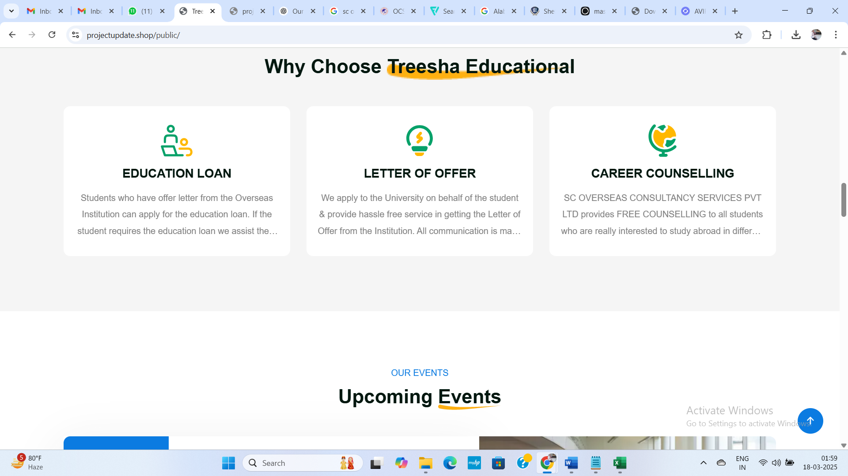
Heading ta Hobe : Why Choose Treesha Educational Services
Educational Loan:
Students with an offer letter from an overseas institution can apply for an education loan. We assist in document preparation, ensuring a smooth process. Loan amounts start from ₹4 lakhs, depending on eligibility and requirements.
Letter of Offer:
We apply to universities on behalf of students, ensuring a seamless process in obtaining the Letter of Offer. Overseas Consultancy Services handles all communication with institutions, providing continuous support up to the orientation stage.
Career Counselling:
Treesha Educational services offers free counseling for students aspiring to study abroad at various international institutions. Get expert guidance and support—contact us to schedule an appointment.

